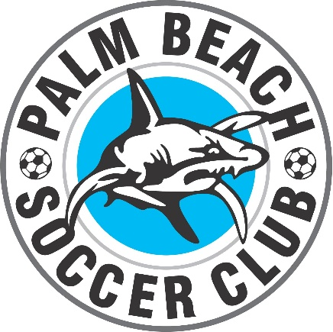

PALM BEACH SOCCER CLUB
REFUND POLICY
REGISTRATION FEES

Should a player change their mind after registering to play with Palm Beach Soccer Club, there is no FULL refund of fees.

1. Once a Palm Beach Soccer Club player has been made “ACTIVE” or been allocated to a team on My Football Club and has not taken the field in a scheduled match for the season, an administration fee of $100 is payable and only the balance of the fees paid to date will be refunded.
2. Once a Palm Beach Soccer Club player has been made “ACTIVE” or been allocated to a team on My Football Club and has not taken the field in a scheduled match for the season, has been given their training kit/uniform, the cost of the gear along with an administration fee of $100 is payable and only the balance of the fees paid to date will be refunded.
3. Once a player has taken the field in a scheduled match be it pre-season or competition, even for the shortest period of time, there is NO REFUND of registration fees. All outstanding balance for registration fees will be due to be paid in full before Palm Beach Soccer Club will release the player from the club.
4. Should the player be unable to play due to circumstances such as injury which will render them unable to play for the season, on receipt of a Doctors Certificate the club will assess and look to refund only a pro rata portion of fees which will be part of the club portion only. The federation fees, FFA, Football Qld and Football GC are non refundable.
5. ANY PLAYER WISHING TO MOVE FROM PALM BEACH SOCCER CLUB TO GOLD COAST CITY FC during the course of the year will receive no refund of their fees from Palm Beach Soccer Club and be liable for the FULL registration fees for Gold Coast City FC. These entities are separate.
8. UNTIL ALL REGISTRATION FEES HAVE BEEN PAID OR PLAYER’S HAVE ADHERED TO ABOVE CONDITIONS – NO PLAYER WILL BE RELEASED ON MYFOOTBALLCLUB BY PALM BEACH SOCCER CLUB.

